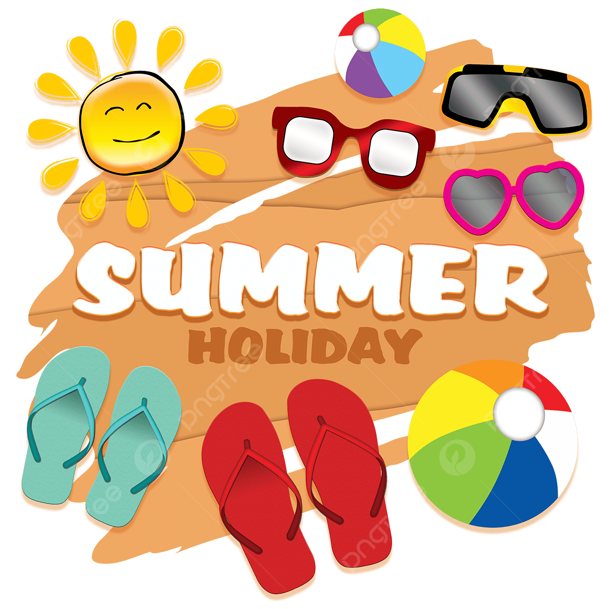
Summer-Holiday Checklist
- Re-check document
- Re-check flight details
- Turn off all plugs
- Lock all doors
- Flush toilets and add bleach
- Take travel sickness tablets
- Turn on alarm
Day Of Travel
- Scan and email all document to yourself
- Inform bank if going abroad
- Print boarding passes
- Check phone roaming charges
- Book airport parking
- Plan journey
- Empty the bins
- Water the plants
- Set timer for light
- Turn of appliances
- Lock all windows
- Make sure washing machine is empty
- Check fuel in car
- Check journey times
Week Before
Day Before
- Check Passports are valid
- Apply for visas
- Book required vaccination
- Sort care for animals
- Take out travel insurance
When You Book

